Samwel, Youssef

Microwave Engineering - HW5

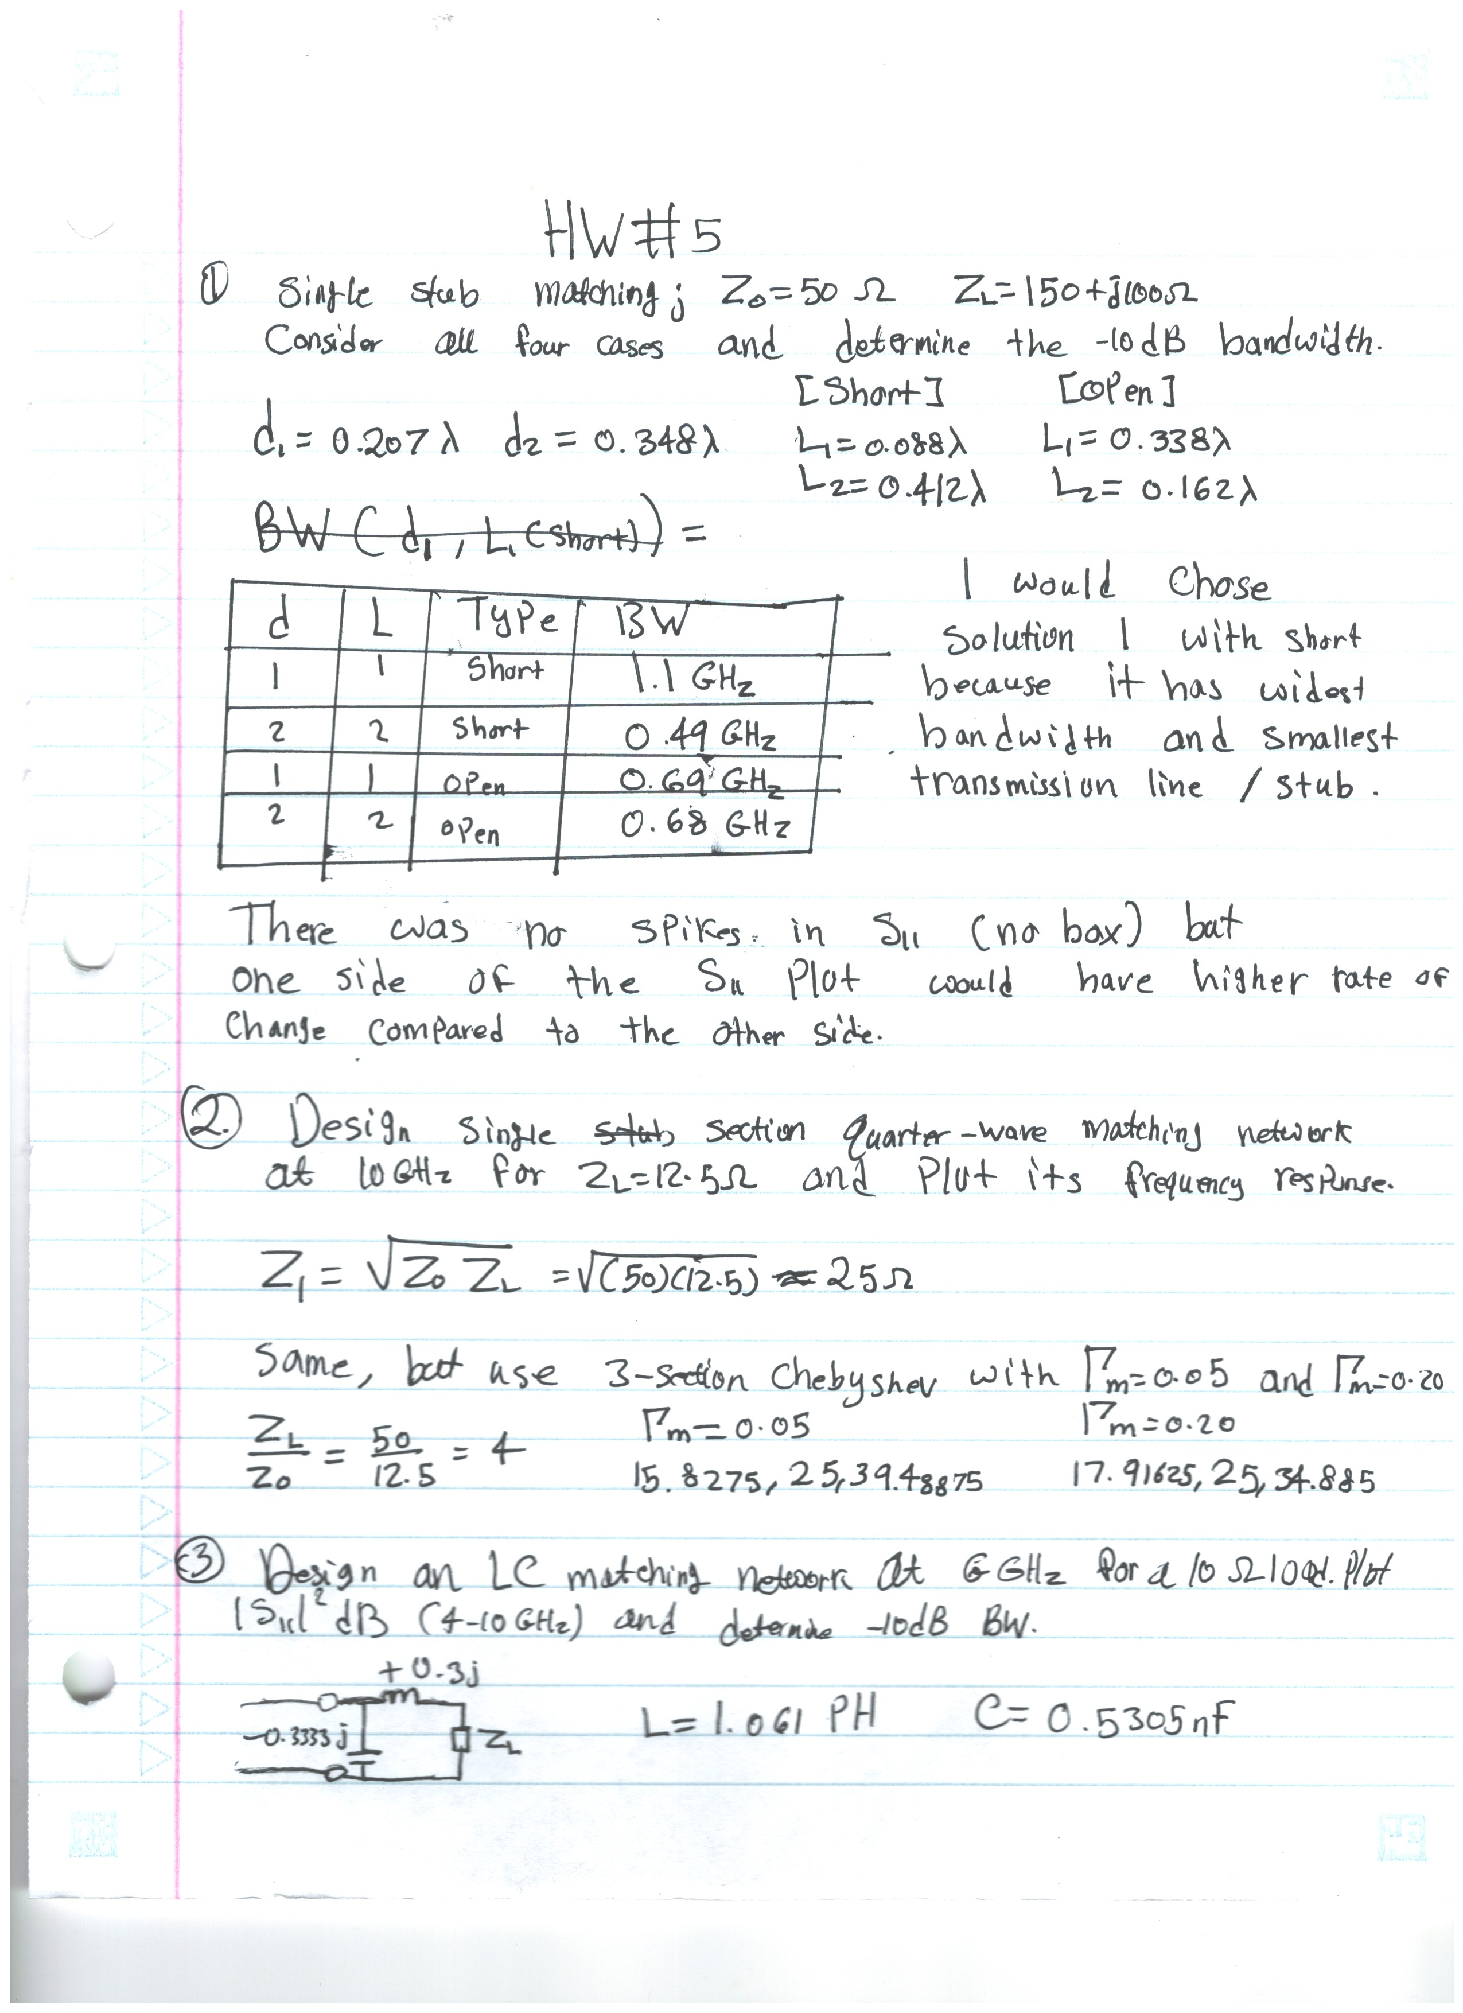

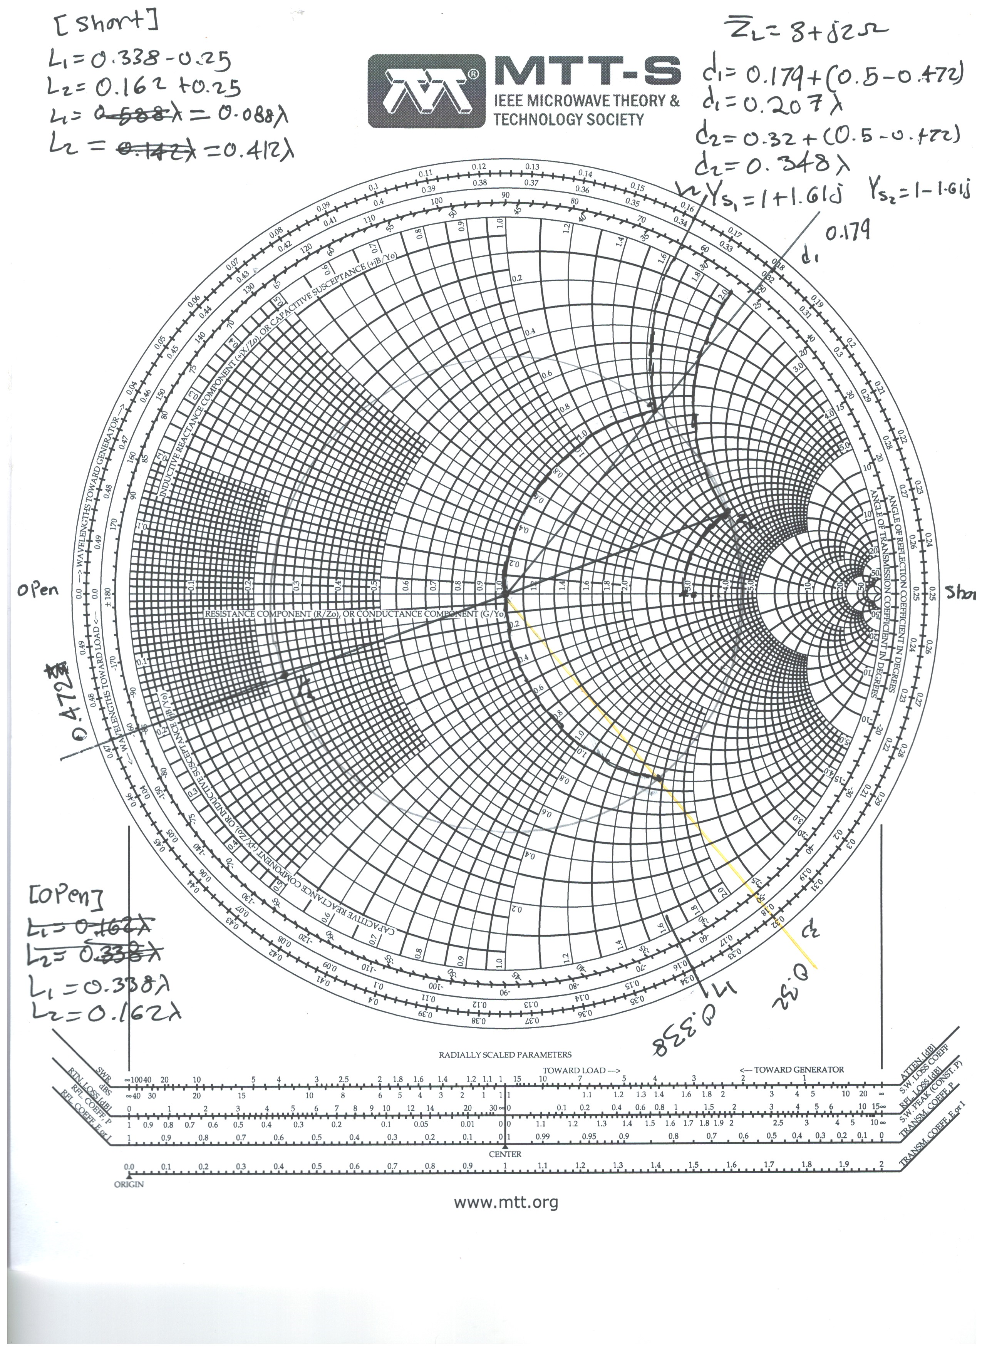

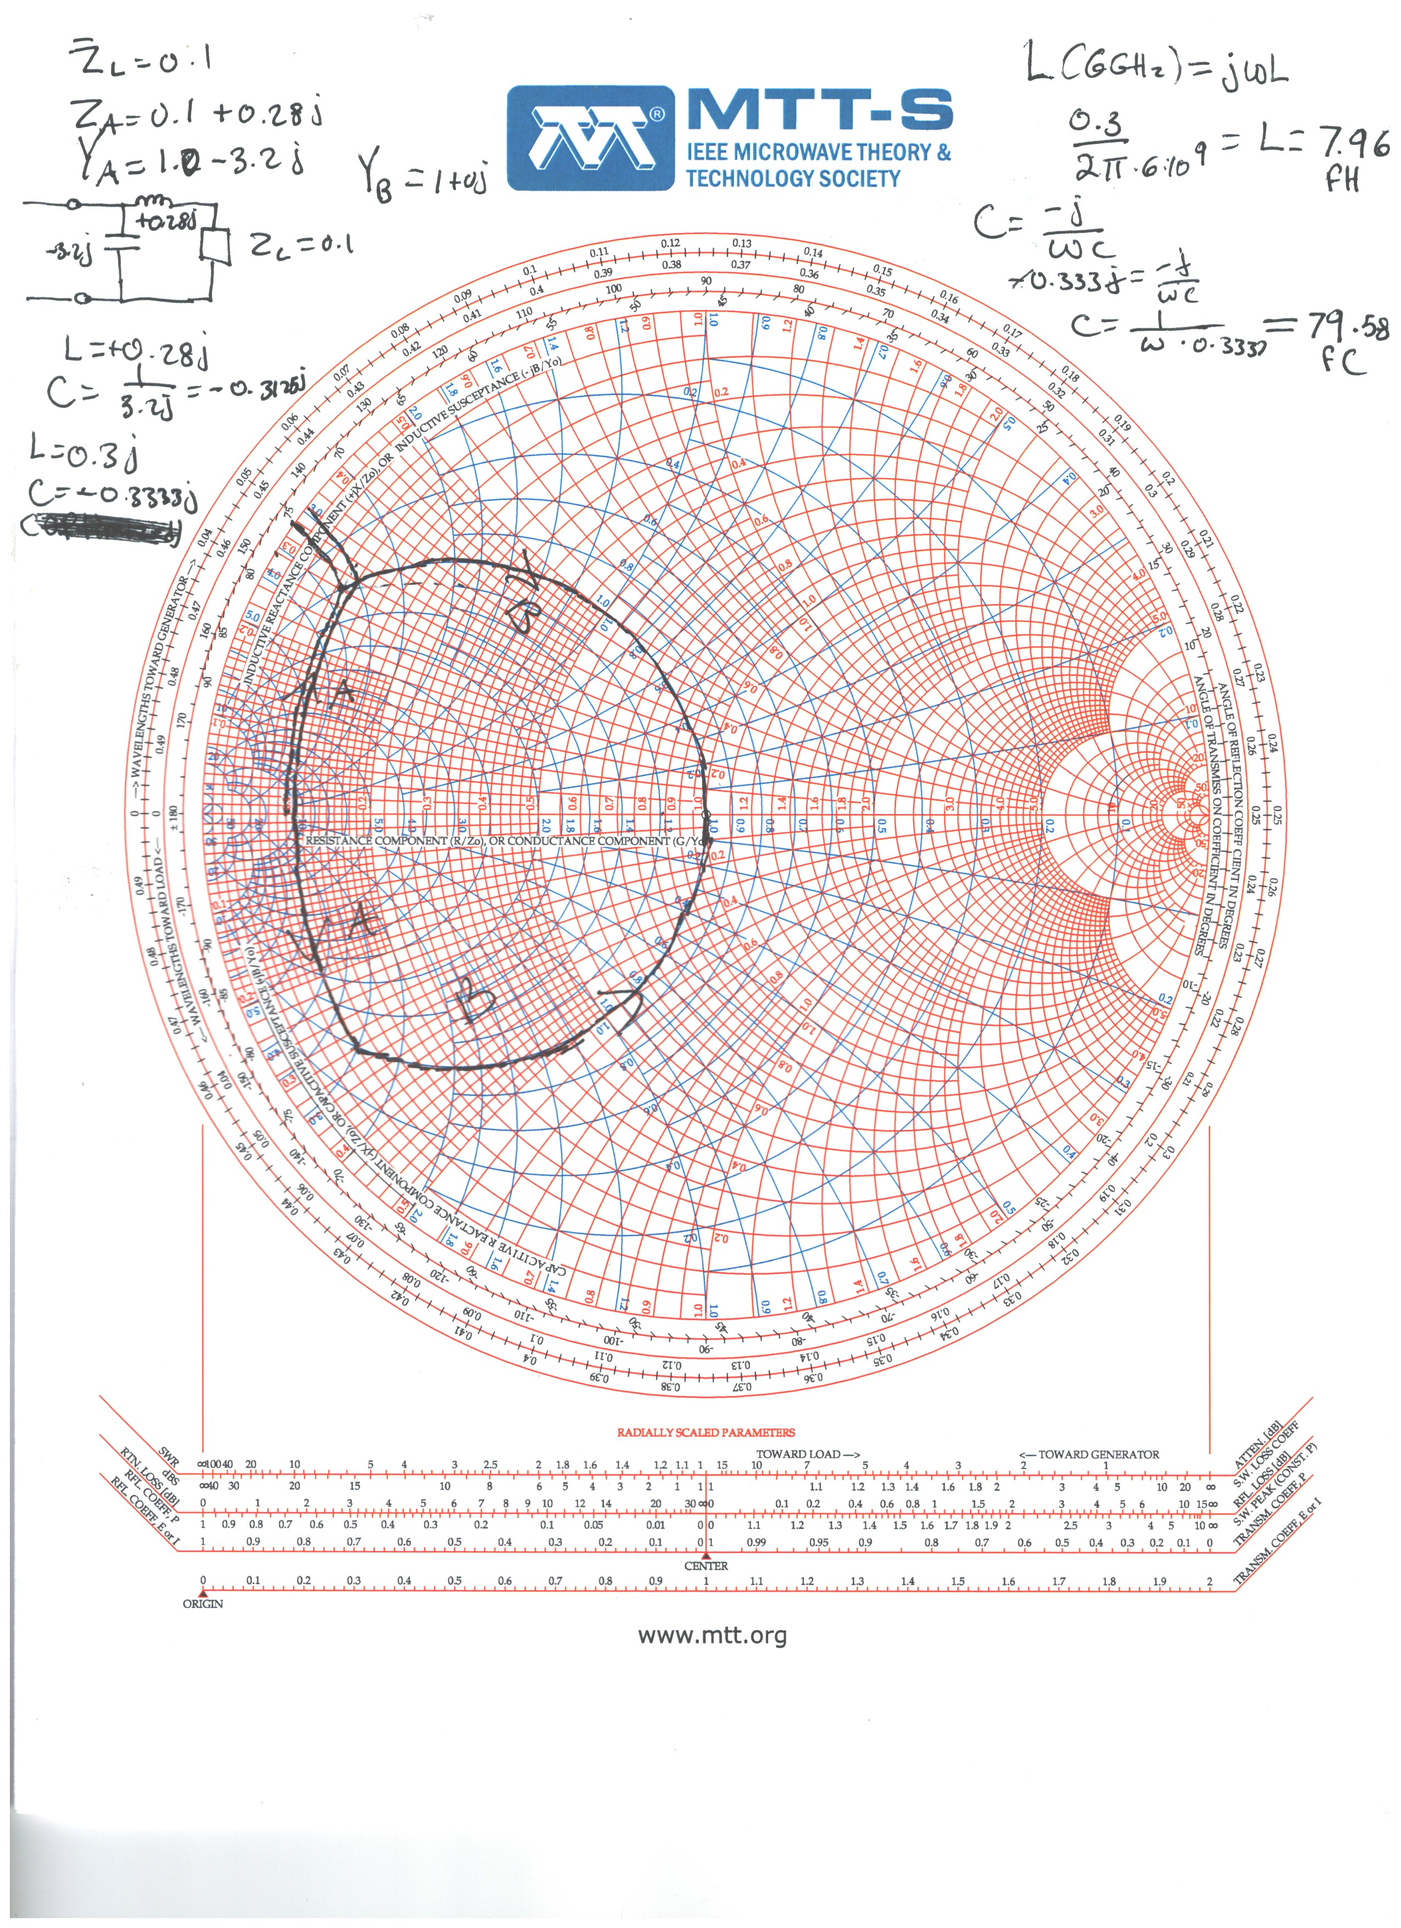

# Question 1 Plots

Short; Solution 1, Circuit



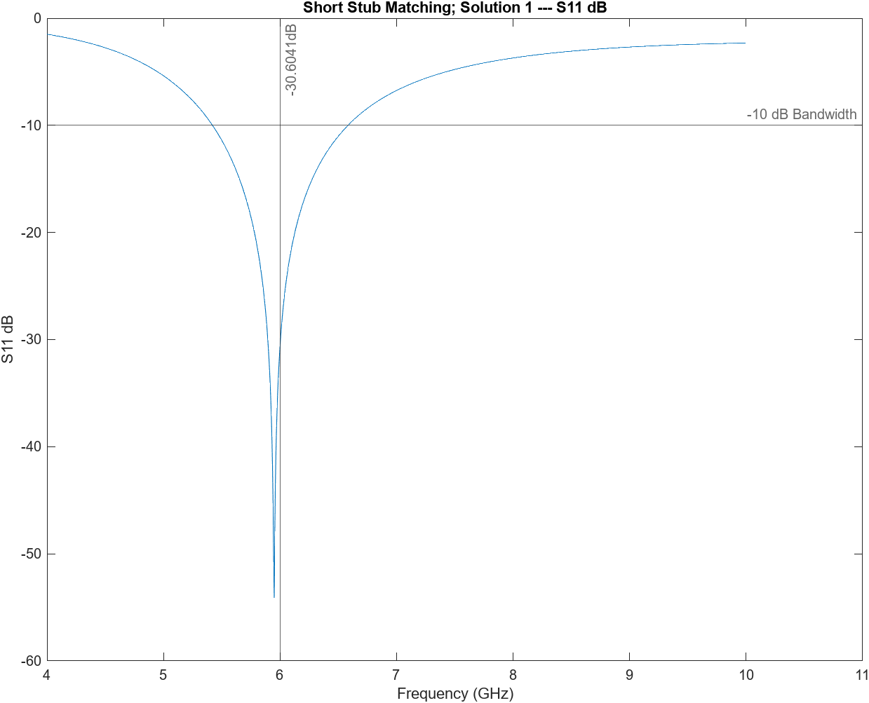

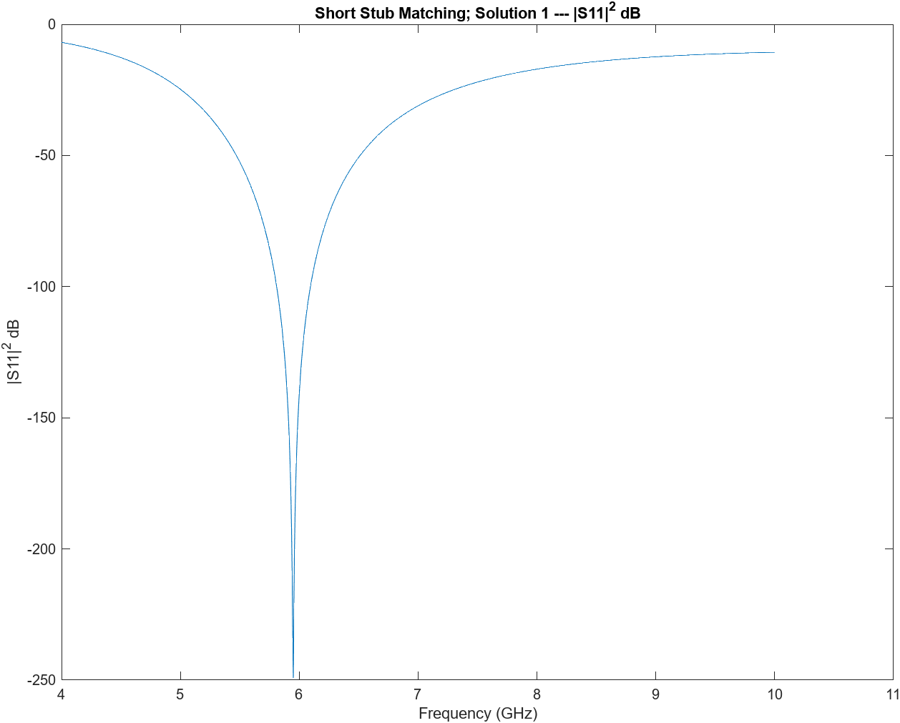

Short; Solution 1, Circuit



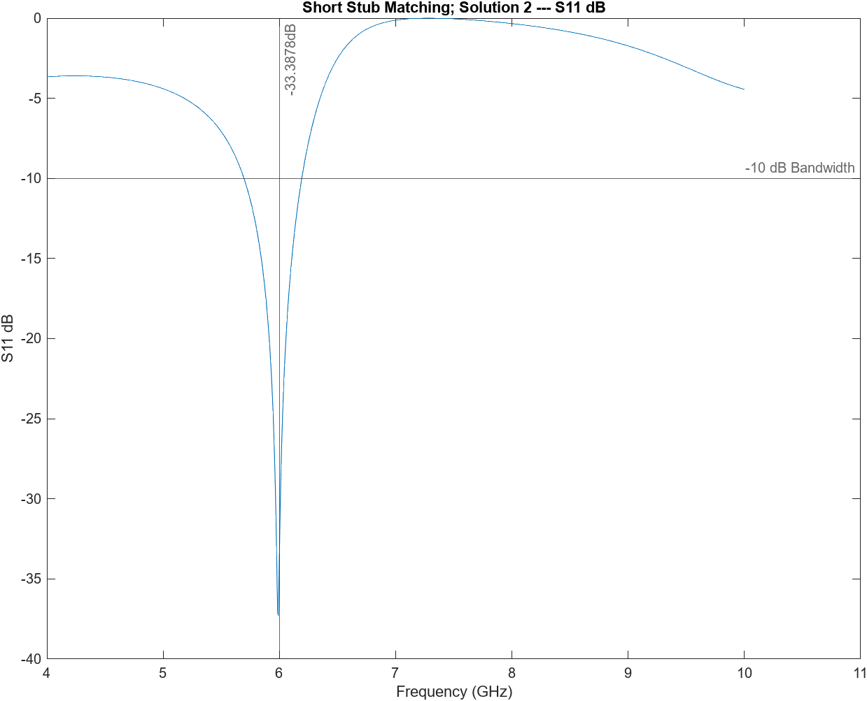

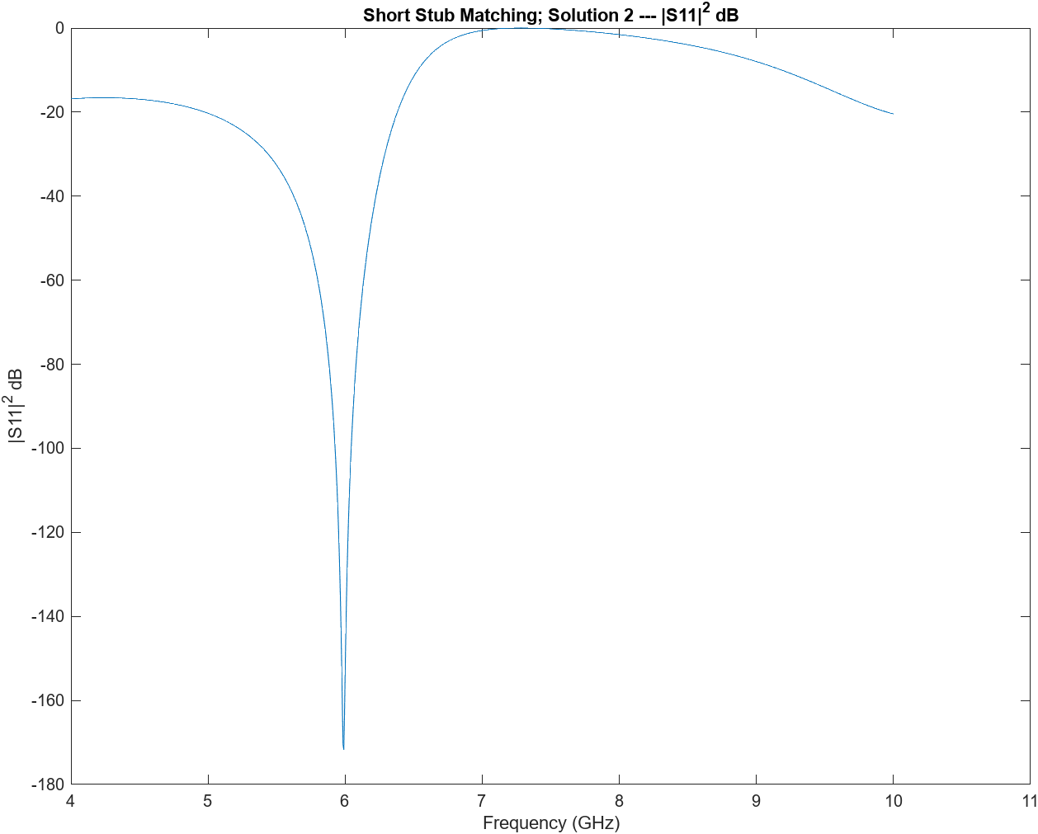

Open; Solution 1, Circuit



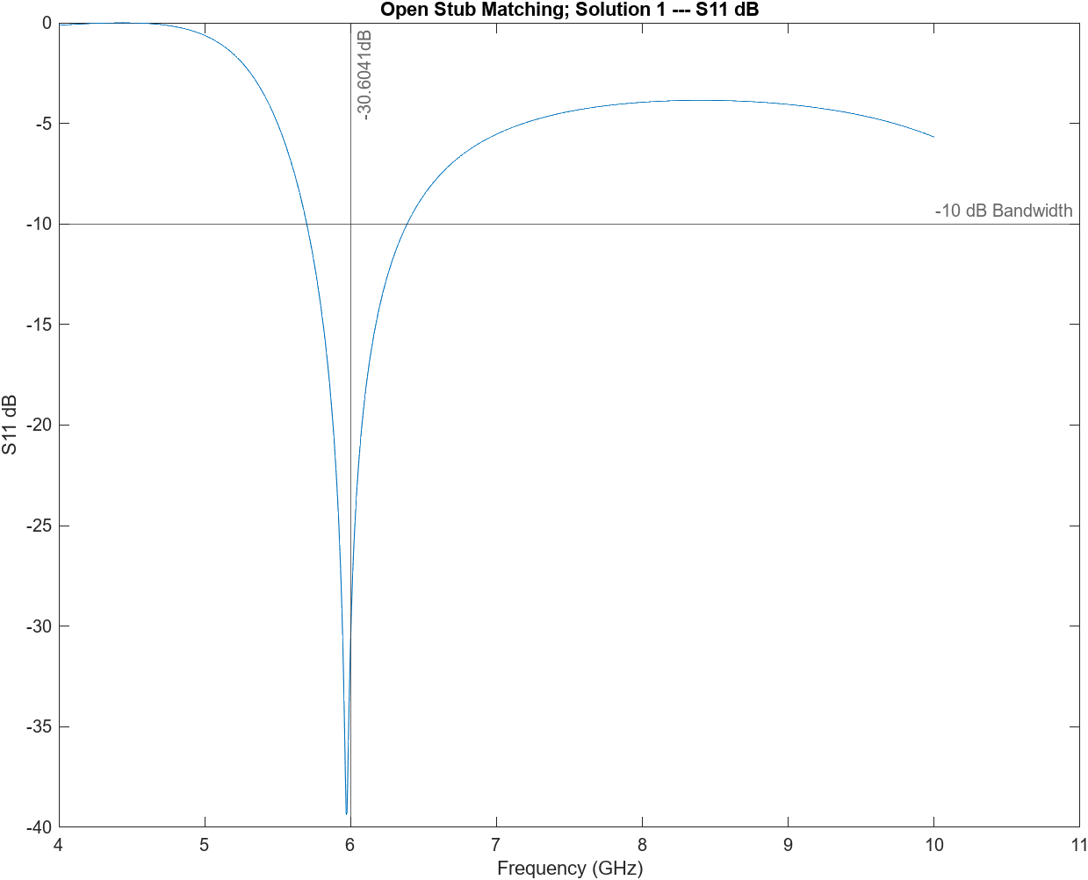

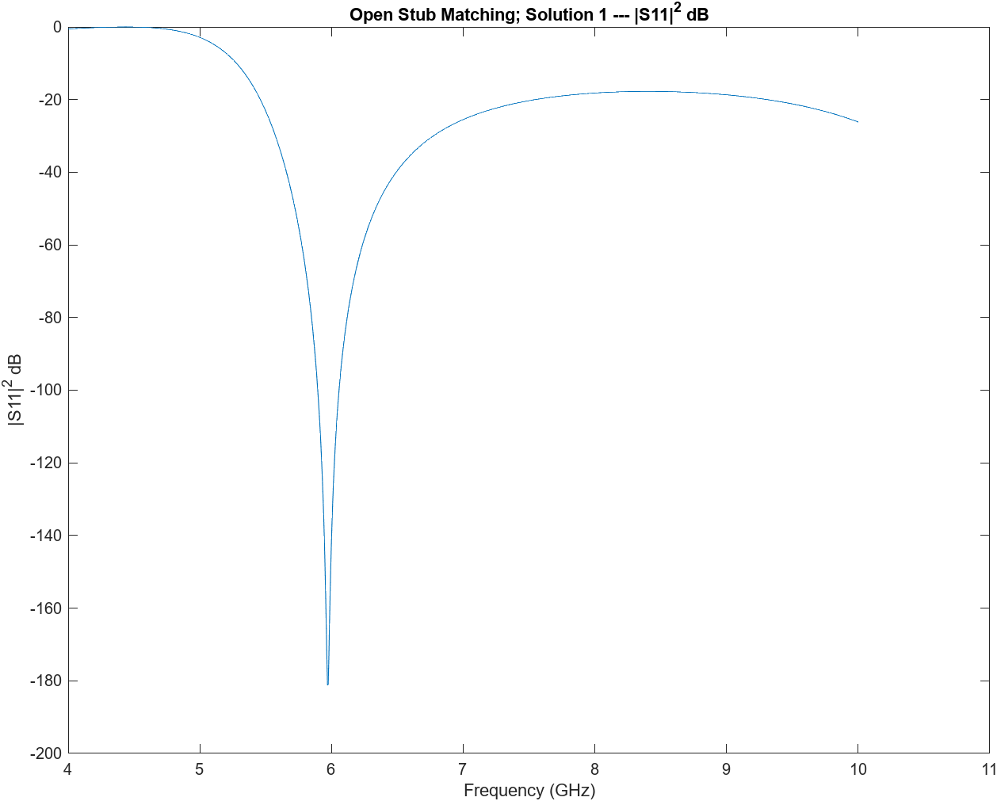



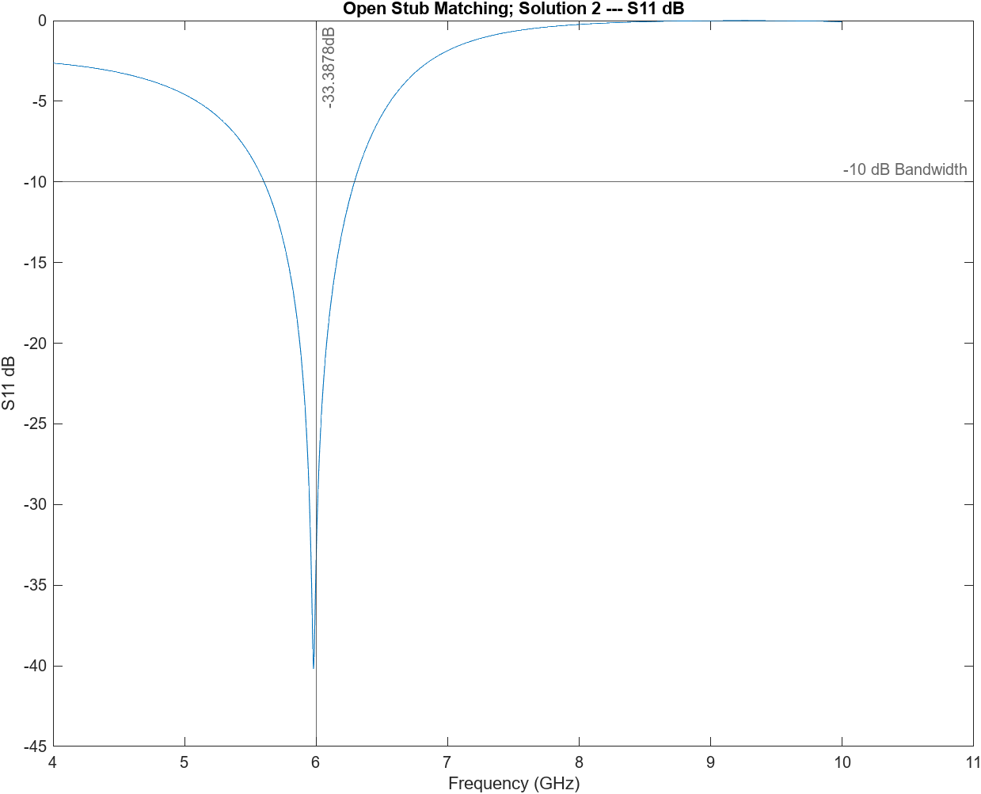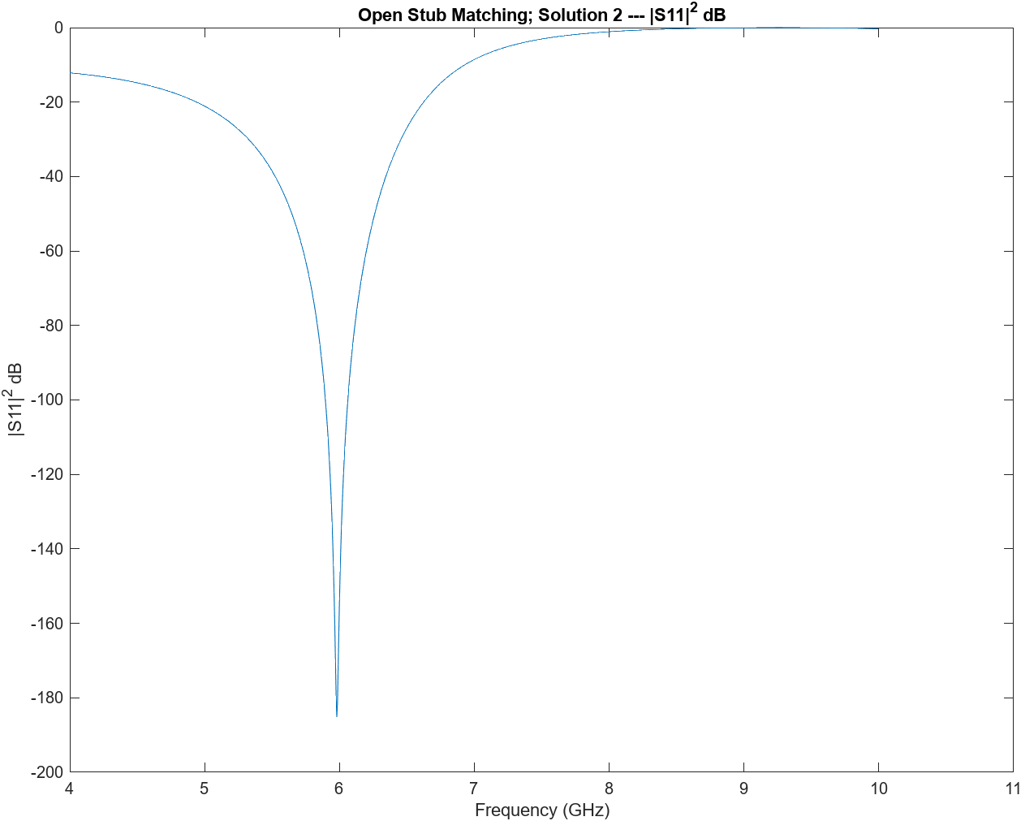

# Question 2 Plots



Single Section Matching Circuit

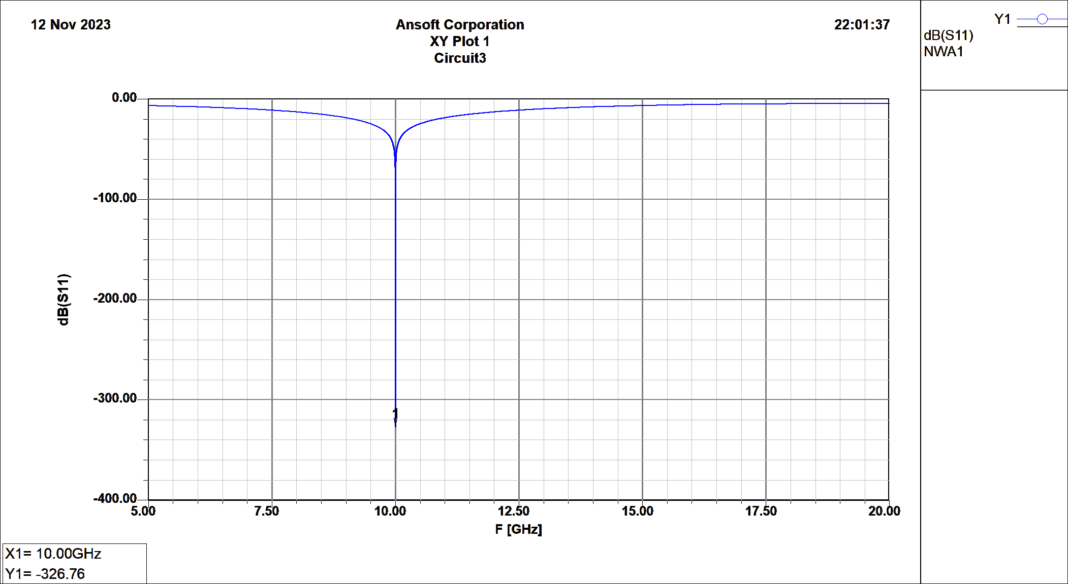

S11 dB Plot



3-Section Matching Circuit with $Γ_{m}=0.05$

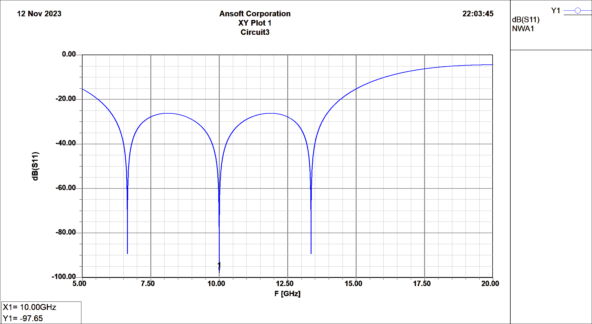

S11 dB Plot



3-Section Matching with $Γ_{m}=0.20$

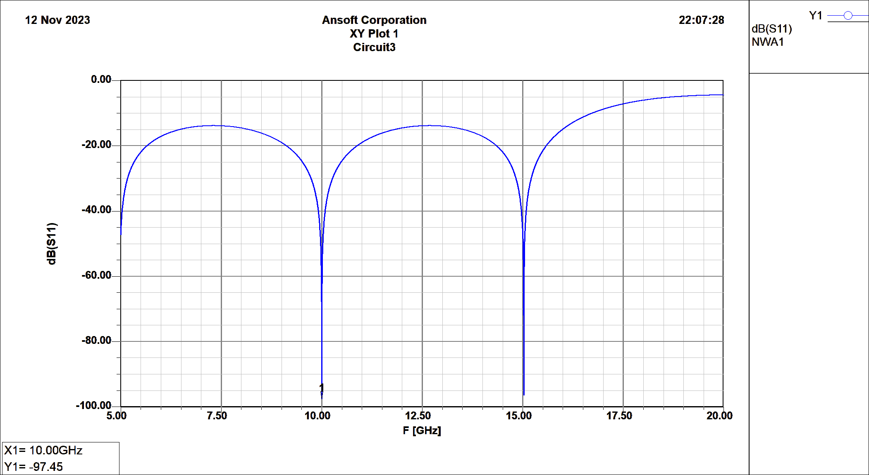

S11 dB Plot

# Question 3 Plots



LC Matched Network

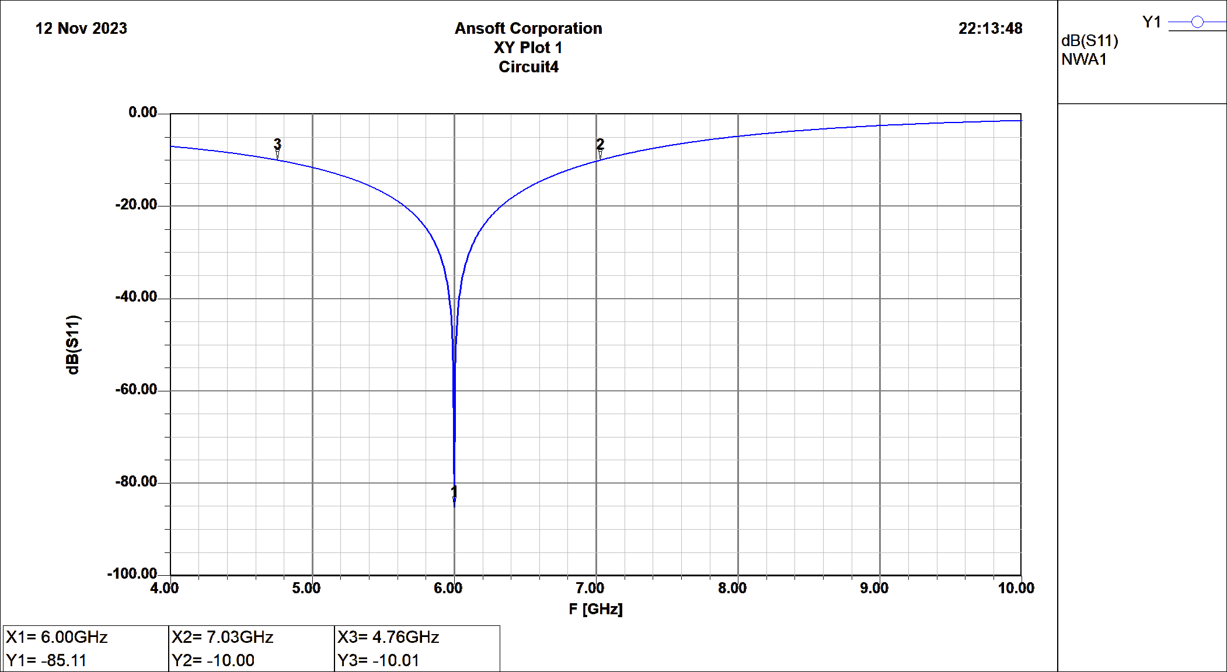

S11 dB Plot



Replaced with Transmission Lines

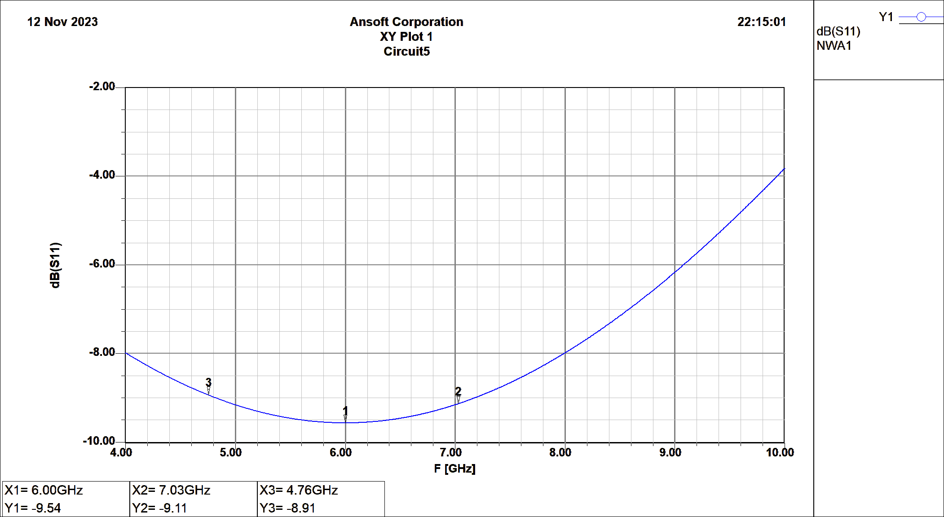

S11 dB Plot

# MATLAB Code

Used to generate figures.

% parameters

close all

clc

file = "Open_Sol2.csv";

s11_title = "Open Stub Matching; Solution 2";

% plot generation

data = table2array(readtable(file));

x = data(:,1);

y = data(:,2);

% Plot S11 db

f = figure;

f.Position = [100, 100, 960, 720];

plot(x, y);

xlabel("Frequency (GHz)");

ylabel("S11 dB");

title(s11_title + " --- S11 dB");

yline(-10,'','-10 dB Bandwidth');

xline(6,'',interpolateYValue(x, y, 6) + "dB");

% convert S11 db to magnitude

y = 10.^(y./20);

y = y .* y;

% convert S11 mag to db

y = 20 .* log(y);

f = figure;

f.Position = [100, 100, 960, 720];

plot(x, y);

title(s11_title + " --- |S11|^2 dB");

ylabel("|S11|^2 dB");

xlabel("Frequency (GHz)");

function interpolatedY = interpolateYValue(X, Y, requestedX)

    % Check if the requested X value is in the range of the known X values

    if requestedX >= min(X) && requestedX <= max(X)

        % If the requested X value exists in the X array, find the corresponding Y value

        if any(X == requestedX)

            % Get the exact Y value for the requested X

            index = find(X == requestedX);

            interpolatedY = Y(index);

        else

            % Interpolate the Y value for the requested X

            interpolatedY = interp1(X, Y, requestedX, 'linear');

        end

    else

        error('Requested X value is outside the range of known X values.');

    end

end